STRESS ANALYSIS OF xxxxxxx

Structure: xxxxxxx

Prepared By,

0 |  | First issue
Rev. | Date | Revision Details | Prepared by | Checked by | Approved by

THIS DOCUMENT HAS BEEN PREPARED ON THE BASIS OF INFORMATION AND DATA PROVIDED BY CLIENT WITHOUT ANY INDEPENDENT VERIFICATION. SHIRSH DOES NOT GUARANTEE OR WARRANT THE ACCURACY, RELIABILITY AND COMPLETENESS OF THE INFORMATION IN THIS REPORT NOR ITS USEFULNESS WHEN OPERATING UNDER CONDITIONS DIFFERENT THAN THOSE STATED IN REPORT. THE CLENT MUST NOTIFY SHIRSH IN A TIMELY MANNER OF ANY DISCREPENCIES, ERRORS OR OMMISIONS THAT MAY REQUIRE THE ATTENTION OF SHIRSH TO CORRECT.
Contents
1) Introduction: 3
2) Assumptions: 3
3) Analysis Details: 3
4) 3D Geometric Model: 3
5) Element Plot: 4
6) Material Data: 4
7) Loads: 5
8) Load Cases: 5
9) Boundary conditions and loads: 5
10) Deformation Plot: 7
11) Stress plots 8
12) Results: 10
13) Conclusion: 10

List of figures
Figure 1 3D Geometrical Model 3
Figure 2 Finite Element Model 4
Figure 3 : Loading condition LC-1 6
Figure 4 : Loading condition LC-2 6
Figure 5 Total deformation plot for load case LC1 (Scaled : 1x) 7
Figure 6 Total deformation plot for load case LC2 (Scaled : 1x) 7
Figure 7 Maximum Principal stress plot for load case LC-1 8
Figure 8 Maximum Principal stress plot for load case LC-2 8
Figure 9 Failure Plot (Coulomb – Mohr Theory) for LC1 9
Figure 10 Failure Plot (Coulomb – Mohr Theory) for LC2 9

List of tables
Table 1 Analysis Details 3
Table 2 Laminate Thicknesses 5
Table 3 Laminate Material Data 5
Table 4 Results summary 10

Introduction:
To perform Finite Element Analysis for TATA EMVEE 35 mm Solar Panel frame under Wind and snow load.
To evaluate the failure status of Aluminium frame, Coulomb – Mohr theory for brittle material failure is used; which states that fracture occurs when the maximum and minimum principal stresses combine for a condition which satisfies the following :

$$\frac{σ_{1}}{S_{ut}}-\frac{σ_{3}}{S_{uc}}≥1$$

Where, $S_{ut}$and $S_{uc}$ represent the ultimate tensile and compressive strengths, and $σ_{1}$ and $σ_{3}$ are maximum and minimum principal stresses; which means if the left hand side, i.e, Coulomb – Mohr factor (CMF) >1, the component fails.

Assumptions:
The analysis has been carried out with following assumptions.
- Live loads (L), Self-restraining loads (T) and any other loads are not applicable.
- Structural members are homogenous and do not contain defects.
- Member connections are infinitely rigid.
- Model is made quarter symmetric, for ease in analysis.

Analysis Details:
Table 1 Analysis Details
Software | NASTRAN
Analysis type | Static structural, Nonlinear Elastic - plastic
Element type | SOLID3D (CHEXA, CTETRA, CPENTA, CPYRAM)
Unit System | SI system

3D Geometric Model:
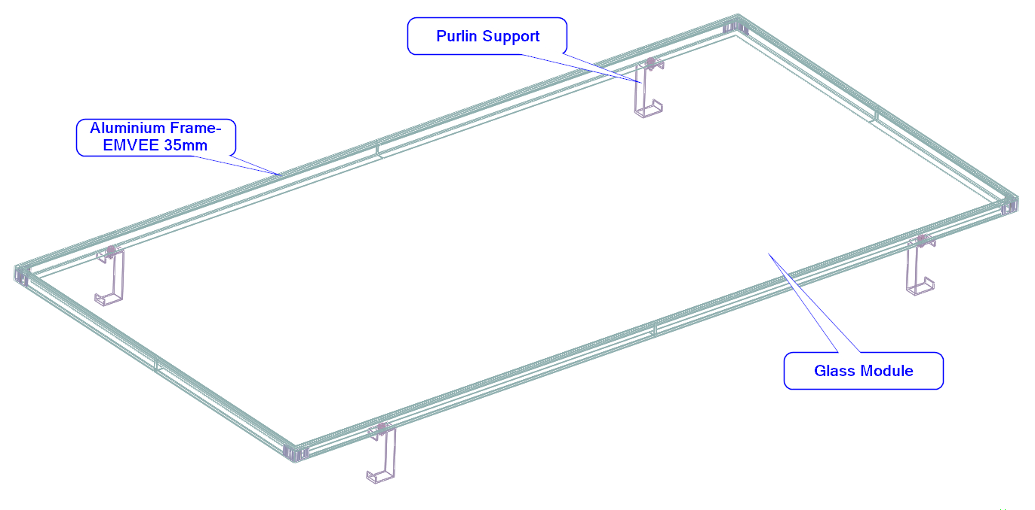
Figure 1 3D Geometrical Model

Element Plot:
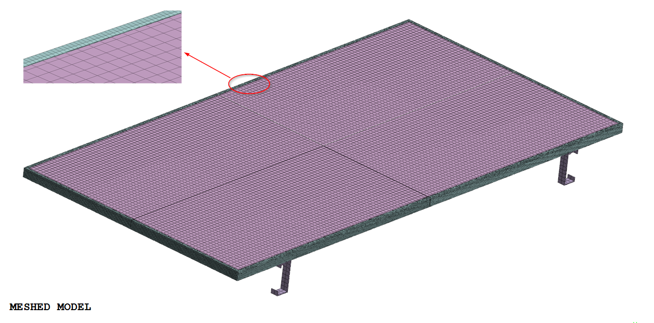
Figure 2 Finite Element Model

Material Data:

Material property for Aluminum Alloy (AL-6063-T5) :

Table 2 Laminate Thicknesses
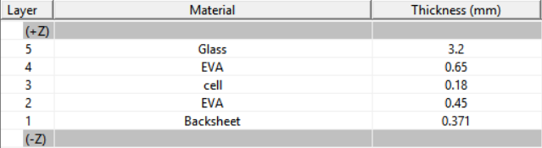
Layer 1 is on the bottom. Subsequent layers are added to the top, increasing in the +Z normal direction.
Table 3 Laminate Material Data

Sr. No. | Material | Properties
 |  | E (MPa) | P.R.
1 | Aluminum Alloy (AL-6063-T5) | 68900 | 0.33
2 | Backsheet | 2138 | 0.35
3 | Silicon cell | 1.625 ×10⁵ | 0.3
4 | EVA sheet | 394 | 0.29
5 | Glass | 73000 | 0.2
E- Modulus of Elasticity, P.R.- Poisson’s Ratio

Loads:
The analysis aims to provide the verification of structural stability considering wind and snow loads for the solar panel frame by means of the Finite-Element-Method (FEM).
Following Pressure magnitude is applied on Panel face.
            - Wind load- 2400 Pa.
            - Snow load – 5400 Pa

Load Cases:

- LC1 – Wind load
- LC2 – Snow Load

Boundary conditions and loads:

  - Purlin is constrained in all directions.
  - Frame is constrained at bolting locations.
  - Wind and snow pressure is applied normal to Panel face.

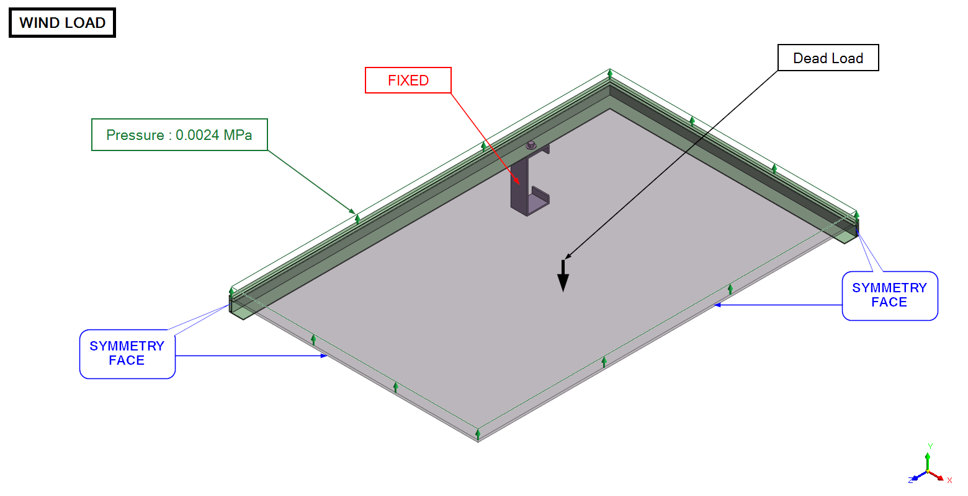

Figure 3 : Loading condition LC-1

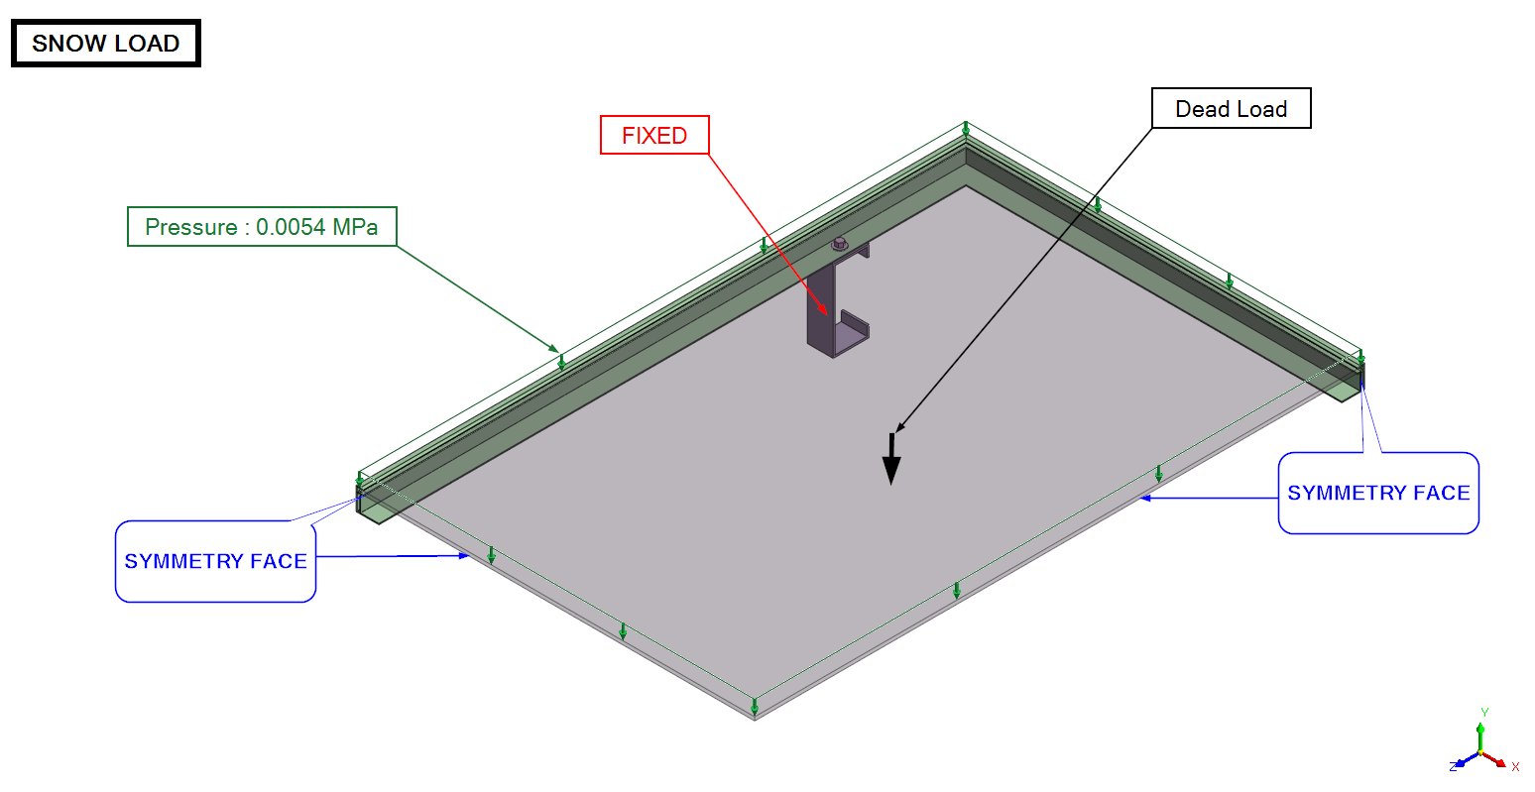

Figure 4 : Loading condition LC-2

Deformation Plot:
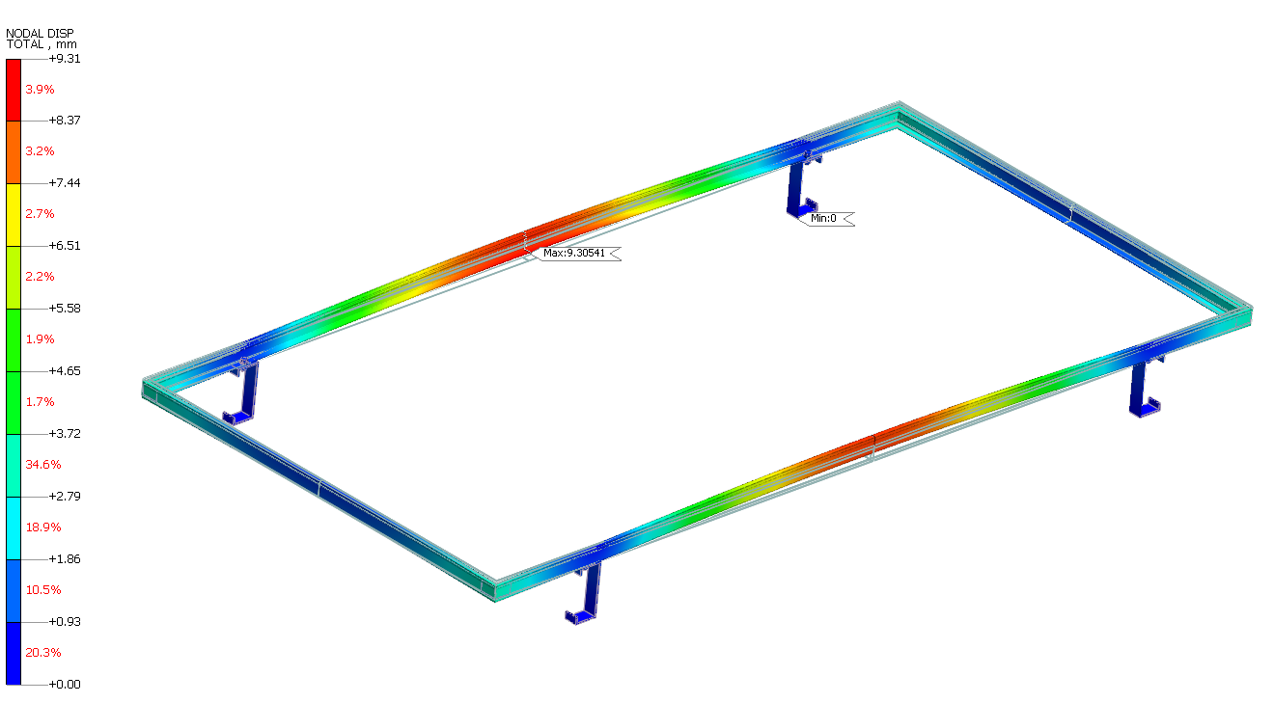
Figure 5 Total deformation plot for load case LC1 (Scaled : 1x)

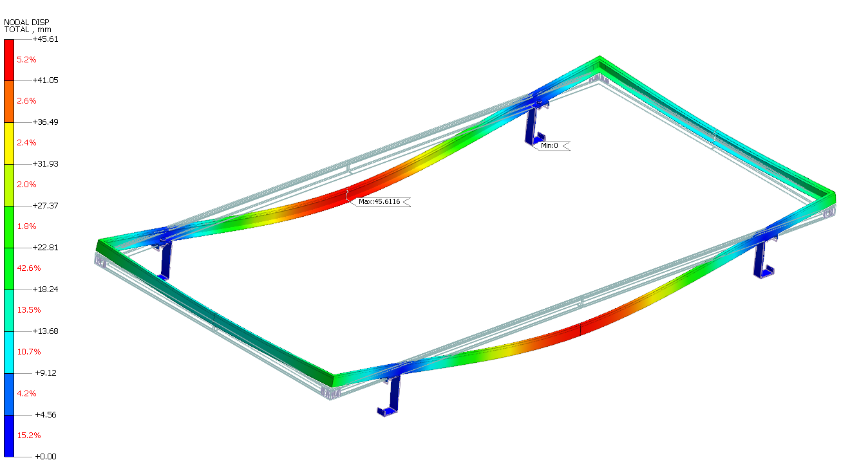
Figure 6 Total deformation plot for load case LC2 (Scaled : 1x)

Stress plots

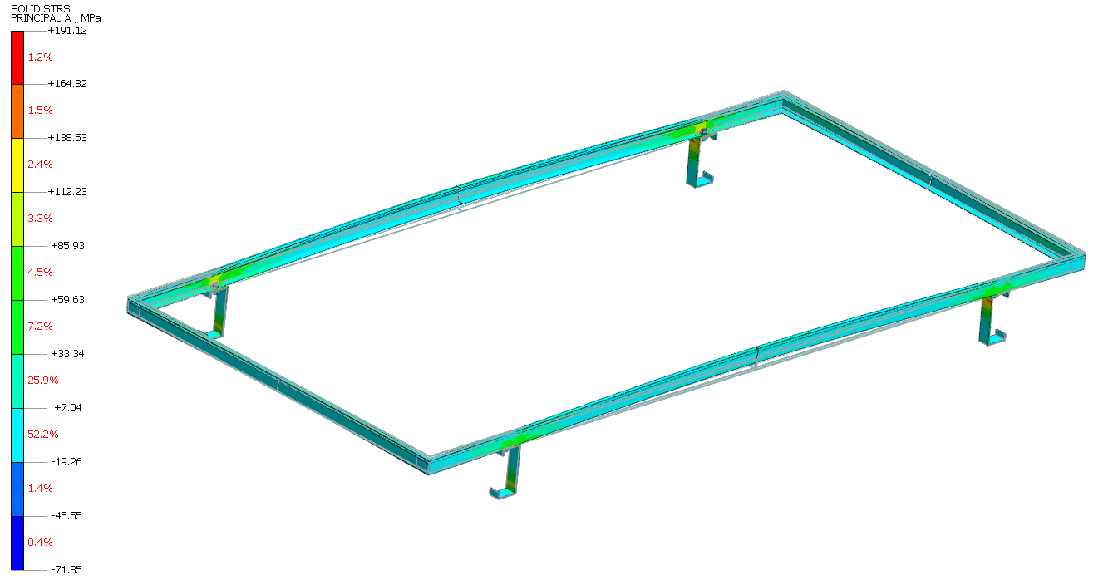
Figure 7 Maximum Principal stress plot for load case LC-1

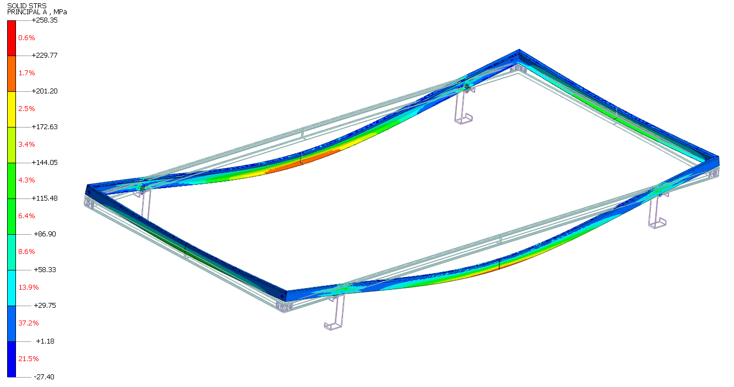
Figure 8 Maximum Principal stress plot for load case LC-2

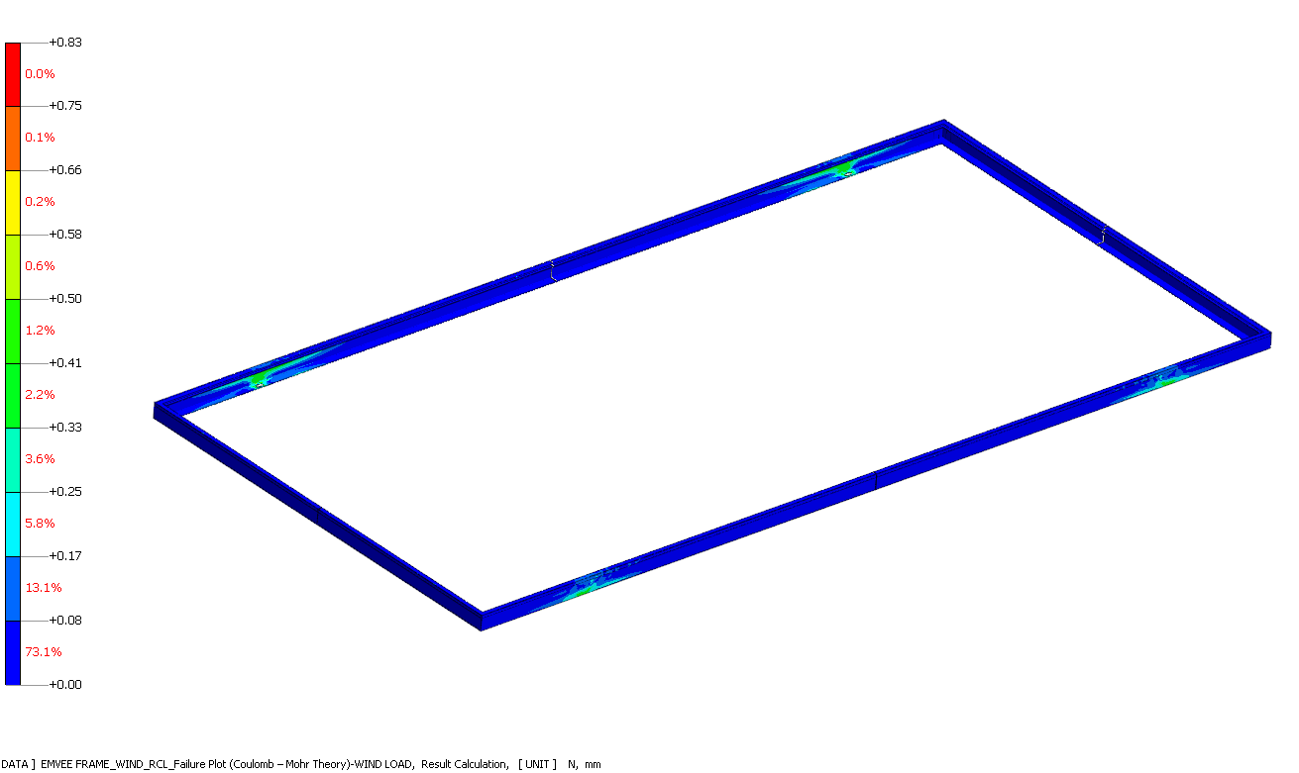
Figure 9 Failure Plot (Coulomb – Mohr Theory) for LC1

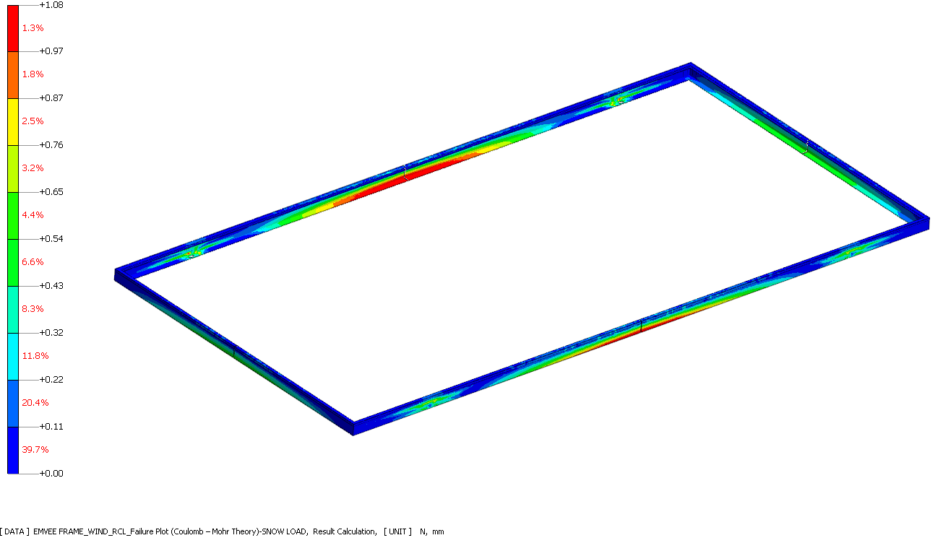
Figure 10 Failure Plot (Coulomb – Mohr Theory) for LC2

Results:

Table 4 Results summary
Load Case | Induced Deflection  (mm) | Coulomb –Mohr Factor  (CMF) | Allowable Coulomb – Mohr factor (CMF) | Result
LC1 | 9.31 | 0.83 | 1 | PASS
LC2 | 45.61 | 1.08 | 1 | FAIL

Note:
1. Refer section 11) for result plots.
2. Refer Section 1) for Coulomb – Mohr theory for interpretation.

Conclusion:
As shown in Section 12) of this report, calculated CMF is less than 1 for LC1, but greater than 1 for LC2. Hence, the design is considered as FAIL in Snow Loading Condition.

